Question 1

package CIA1;

import org.openqa.selenium.By;

import org.openqa.selenium.JavascriptExecutor;

import org.openqa.selenium.WebDriver;

import org.openqa.selenium.WebElement;

import org.openqa.selenium.chrome.ChromeDriver;

import org.openqa.selenium.chrome.ChromeOptions;

import org.testng.Assert;

import org.testng.annotations.Test;

import io.github.bonigarcia.wdm.WebDriverManager;

public class question1 {

@Test

public void f() throws InterruptedException {

WebDriverManager.chromedriver().setup();

ChromeOptions co=new ChromeOptions();

co.addArguments("--remote-allow-origin=*");

WebDriver driver=new ChromeDriver(co);

driver.get("https://www.amazon.in/");

driver.manage().window().maximize() ;

String title=driver.getTitle();

System.out.print(title);

String exptit="Online Shopping site in India: Shop Online for Mobiles, Books, Watches, Shoes and More - Amazon.in";

Assert.assertEquals(title,exptit);

driver.findElement(By.xpath("//*[@id=\"nav-link-accountList-nav-line-1\"]")).click();

driver.findElement(By.xpath("//*[@id=\"ap_email\"]")).click();

driver.findElement(By.xpath("//*[@id=\"ap_email\"]")).sendKeys("+91 7708994112");

driver.findElement(By.xpath("//*[@id=\"continue\"]")).click();

driver.findElement(By.xpath("//*[@id=\"ap_password\"]")).click();

driver.findElement(By.xpath("//*[@id=\"ap_password\"]")).sendKeys("prenesh11");

driver.findElement(By.xpath("//*[@id=\"signInSubmit\"]")).click();

driver.findElement(By.xpath("//*[@id=\"ap_password\"]")).click();

driver.findElement(By.xpath("//*[@id=\"ap_password\"]")).sendKeys("prenesh11");

Thread.sleep(10000);

driver.findElement(By.xpath("//*[@id=\"twotabsearchtextbox\"]")).click();

driver.findElement(By.xpath("//*[@id=\"twotabsearchtextbox\"]")).sendKeys("smartphones");

driver.findElement(By.xpath("//*[@id=\"nav-search-submit-button\"]")).click();

driver.findElement(By.xpath("//*[@id=\"search\"]/div[1]/div[1]/div/span[1]/div[1]/div[5]/div/div/div/div/div/div[2]/div/div/div[1]/h2/a/span")).click();

Thread.sleep(3000);

JavascriptExecutor js=(JavascriptExecutor)driver;

js.executeScript("window.scrollBy(0,500)","");

driver.findElement(By.xpath("//*[@id=\"add-to-cart-button\"]")).click();

driver.findElement(By.xpath("//*[@id=\"attach-sidesheet-view-cart-button\"]/span/input")).click();

driver.findElement(By.xpath("//*[@id=\"nav-cart\"]")).click();

driver.findElement(By.xpath("//*[@id=\"a-autoid-0-announce\"]")).click();

driver.findElement(By.xpath("//*[@id=\"quantity_4\"]")).click();

driver.findElement(By.xpath("//*[@id=\"sc-buy-box-ptc-button\"]/span/input")).click();

}

}

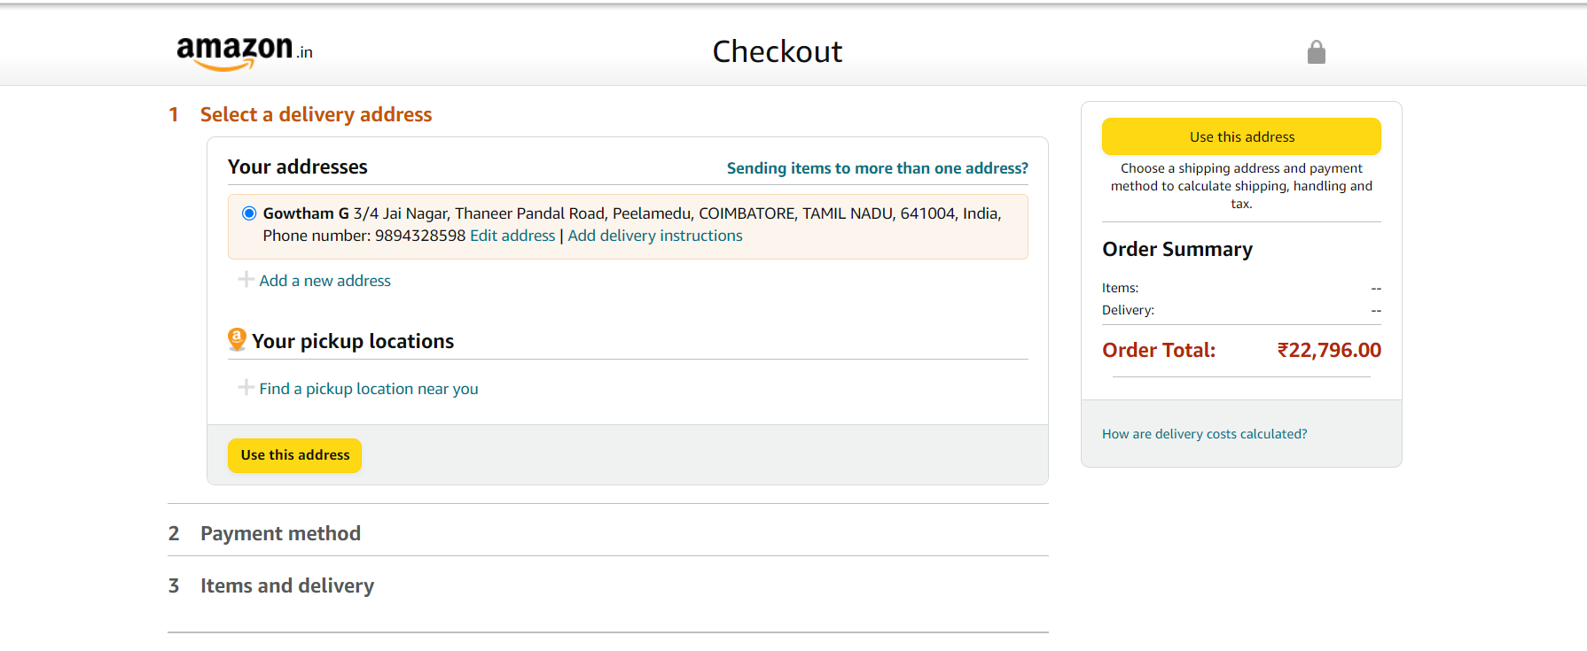

Question 2

package CIA1;

import java.util.List;

import org.openqa.selenium.By;

import org.openqa.selenium.JavascriptExecutor;

import org.openqa.selenium.WebDriver;

import org.openqa.selenium.WebElement;

import org.openqa.selenium.chrome.ChromeDriver;

import org.openqa.selenium.chrome.ChromeOptions;

import org.testng.annotations.Test;

import io.github.bonigarcia.wdm.WebDriverManager;

public class question2 {

@Test

public void f() throws InterruptedException {

WebDriverManager.chromedriver().setup();

ChromeOptions co=new ChromeOptions();

co.addArguments("--remote-allow-origin=*");

WebDriver driver=new ChromeDriver(co);

driver.get("https://www.amazon.in/");

driver.manage().window().maximize() ;

driver.findElement(By.xpath("//*[@id=\"nav-link-accountList-nav-line-1\"]")).click();

driver.findElement(By.xpath("//*[@id=\"ap_email\"]")).click();

driver.findElement(By.xpath("//*[@id=\"ap_email\"]")).sendKeys("+91 7708994112");

driver.findElement(By.xpath("//*[@id=\"continue\"]")).click();

driver.findElement(By.xpath("//*[@id=\"ap_password\"]")).click();

driver.findElement(By.xpath("//*[@id=\"ap_password\"]")).sendKeys("prenesh11");

driver.findElement(By.xpath("//*[@id=\"signInSubmit\"]")).click();

driver.findElement(By.xpath("//*[@id=\"ap_password\"]")).click();

driver.findElement(By.xpath("//*[@id=\"ap_password\"]")).sendKeys("prenesh11");

Thread.sleep(10000);

driver.findElement(By.xpath("//*[@id=\"twotabsearchtextbox\"]")).click();

driver.findElement(By.xpath("//*[@id=\"twotabsearchtextbox\"]")).sendKeys("smartphones");

driver.findElement(By.xpath("//*[@id=\"nav-search-submit-button\"]")).click();

driver.findElement(By.xpath("//*[@id=\"p_89/realme\"]/span/a/div/label/i")).click();

Thread.sleep(2000);

WebElement l1=driver.findElement(By.xpath("//*[@id=\"search\"]/div[1]/div[1]/div/span[1]/div[1]/div[3]/div/div/div/div/div/div[2]/div/div/div[1]/h2"));

WebElement l2=driver.findElement(By.xpath("//*[@id=\"search\"]/div[1]/div[1]/div/span[1]/div[1]/div[4]/div/div/div/div/div/div[2]/div/div/div[1]/h2"));

JavascriptExecutor js=(JavascriptExecutor)driver;

js.executeScript("window.scrollBy(0,300)","");

WebElement l3=driver.findElement(By.xpath("//*[@id=\"search\"]/div[1]/div[1]/div/span[1]/div[1]/div[5]/div/div/div/div/div/div[2]/div/div/div[1]/h2"));

WebElement l4=driver.findElement(By.xpath("//*[@id=\"search\"]/div[1]/div[1]/div/span[1]/div[1]/div[6]/div/div/div/div/div/div[2]/div/div/div[1]/h2"));

WebElement l5=driver.findElement(By.xpath("//*[@id=\"search\"]/div[1]/div[1]/div/span[1]/div[1]/div[7]/div/div/div/div/div/div[2]/div/div/div[1]/h2"));

System.out.println(l1.getText());

System.out.println(l2.getText());

System.out.println(l3.getText());

System.out.println(l4.getText());

System.out.println(l5.getText());

}

}

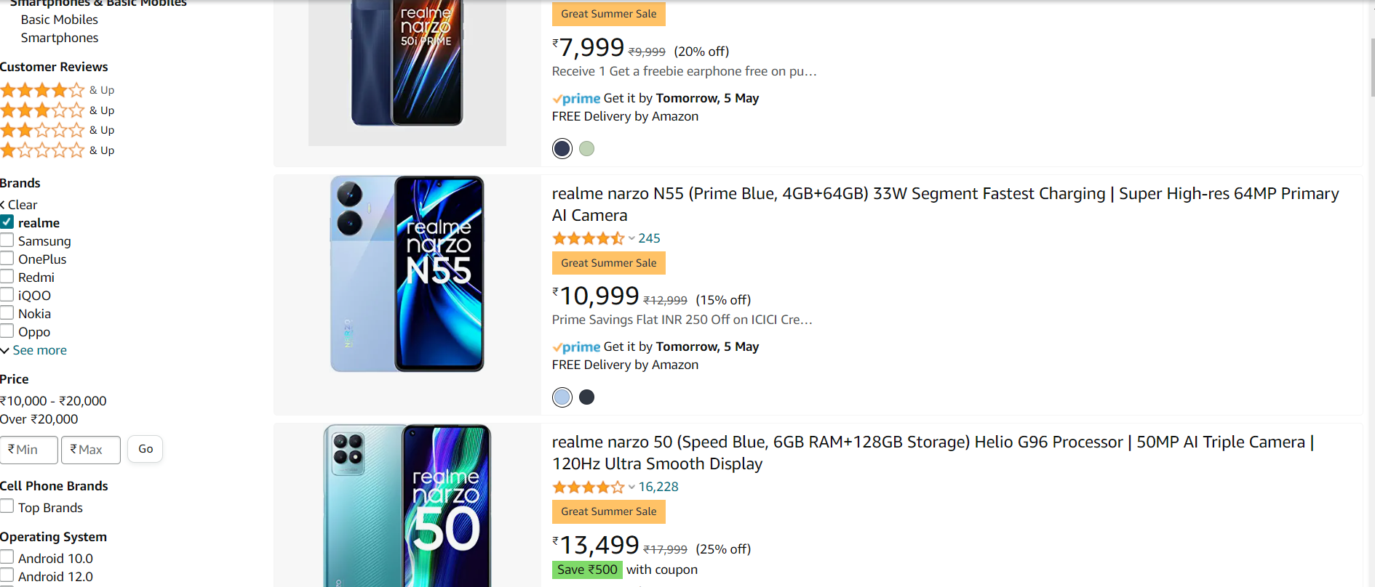

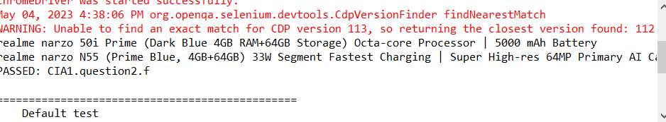

Question 3

package CIA1;

import org.openqa.selenium.By;

import org.openqa.selenium.WebDriver;

import org.openqa.selenium.chrome.ChromeDriver;

import org.openqa.selenium.chrome.ChromeOptions;

import org.testng.annotations.Test;

import io.github.bonigarcia.wdm.WebDriverManager;

public class question3 {

@Test

public void f() throws InterruptedException {

WebDriverManager.chromedriver().setup();

ChromeOptions co=new ChromeOptions();

co.addArguments("--remote-allow-origin=*");

WebDriver driver=new ChromeDriver(co);

driver.get("https://www.amazon.in/");

driver.manage().window().maximize() ;

driver.findElement(By.xpath("//*[@id=\"nav-link-accountList-nav-line-1\"]")).click();

driver.findElement(By.xpath("//*[@id=\"ap_email\"]")).click();

driver.findElement(By.xpath("//*[@id=\"ap_email\"]")).sendKeys("+91 7708994112");

driver.findElement(By.xpath("//*[@id=\"continue\"]")).click();

driver.findElement(By.xpath("//*[@id=\"ap_password\"]")).click();

driver.findElement(By.xpath("//*[@id=\"ap_password\"]")).sendKeys("prenesh11");

driver.findElement(By.xpath("//*[@id=\"signInSubmit\"]")).click();

driver.findElement(By.xpath("//*[@id=\"ap_password\"]")).sendKeys("prenesh11");

driver.findElement(By.xpath("//*[@id=\"ap_password\"]")).click();

Thread.sleep(10000);

driver.findElement(By.xpath("//*[@id=\"nav-link-accountList-nav-line-1\"]")).click();

driver.findElement(By.xpath("//*[@id=\"a-page\"]/div[2]/div/div[2]/div[1]/a/div/div/div")).click();

}

}

